Team : Will Dalton, Ben Gordon, F. Davis Cardwell, Ashley Claire Johnson

***Project Proposal***

**ThunderSnow App**

We are creating a weather dashboard that predicts the accuracy of the National Weather Service API for the DMV area. Our purpose? To tell a story about how accurate the National Weather Service is with predicting the weather. We wanted to do something that would be useful for the area as well as fun to do.

**Tools:**

Heroku server, Flask, Javascript with Leaflet.js, HTML, CSS

**Datasets:**

National Weather Service API - <https://forecast-v3.weather.gov/documentation?redirect=legacy>

Weather for the DMV area - <https://www.weather.gov/lwx/>

Copy of the Metadata - <https://api.weather.gov/gridpoints/LWX/94,69/forecast/hourly>

**Screen Shots of Visualizations That Inspire Us:**

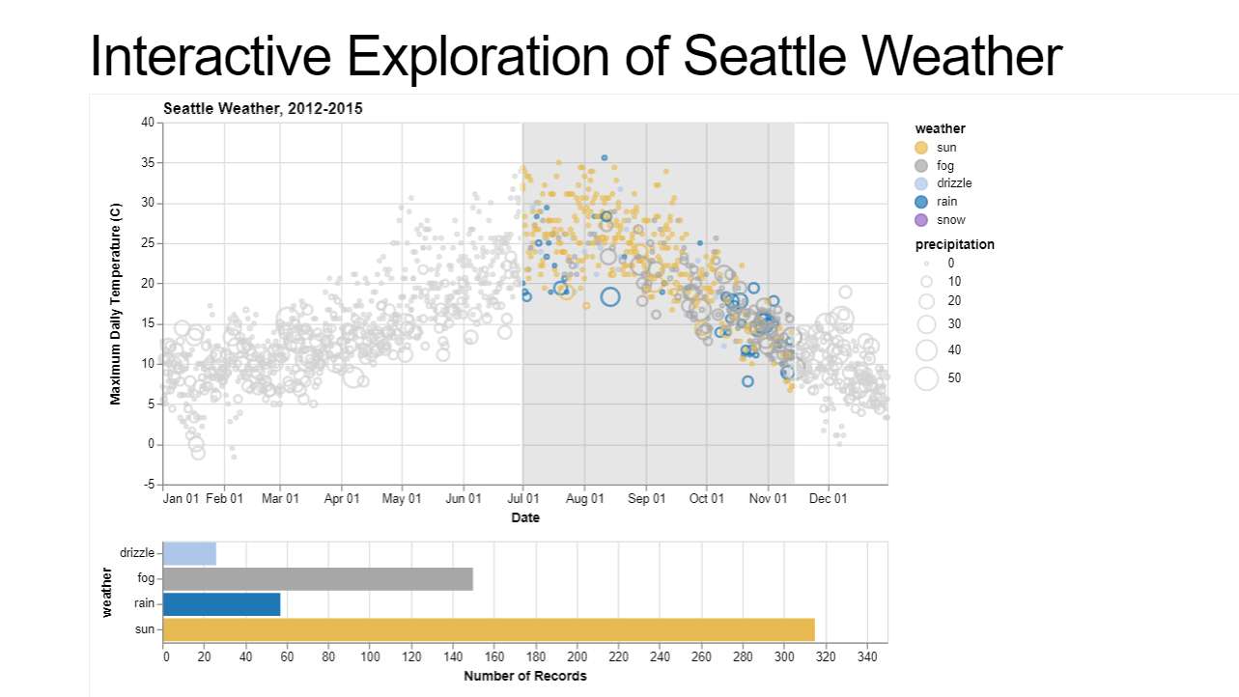

**https://bl.ocks.org/jakevdp/5d1915d808d3d91ce86f0bc3ca066d48**

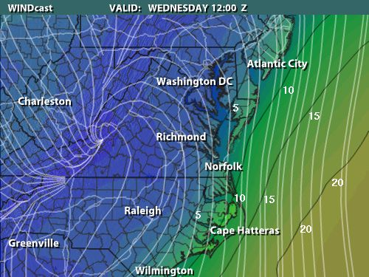

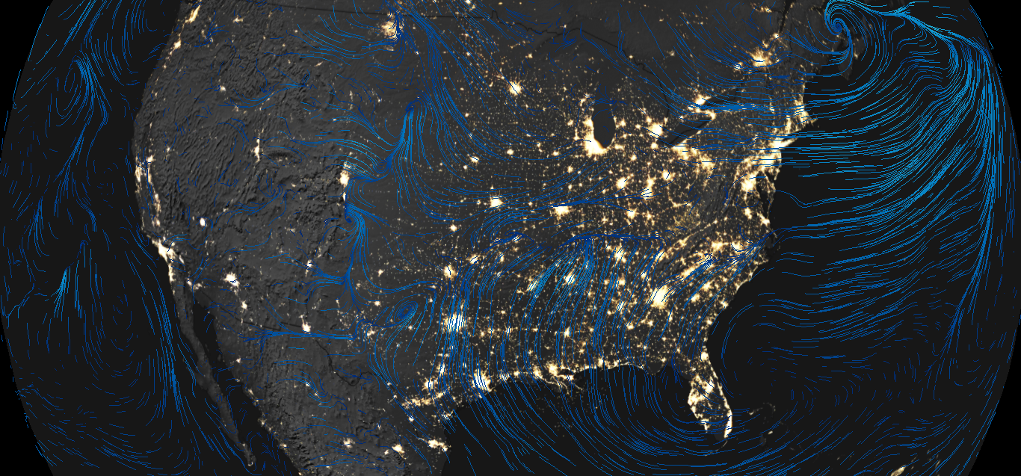

**https://www.nnvl.noaa.gov/weatherview/index.html**

**Rough Sketch of Final Design of Project:**

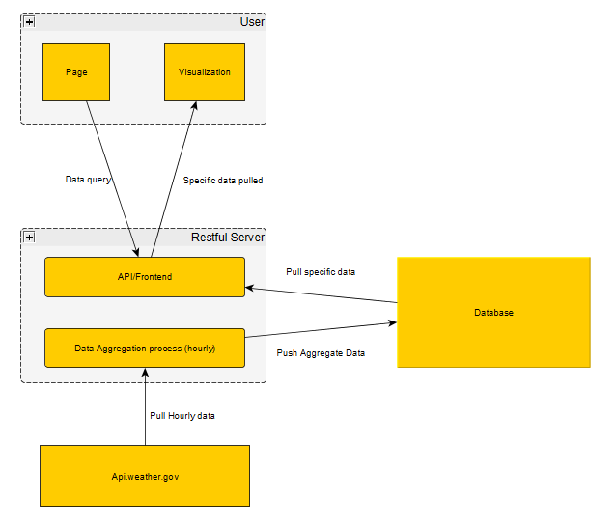**Github Repository:**

<https://github.com/DavisCardwell/Project-2>